Notification System with EntityFrameworkCore

Source Code GitHub Url - https://github.com/Padmavathi-SJ/Presidio-training/tree/main/14-05-2026/NotificationSystem

OUTPUTS:
Menu:
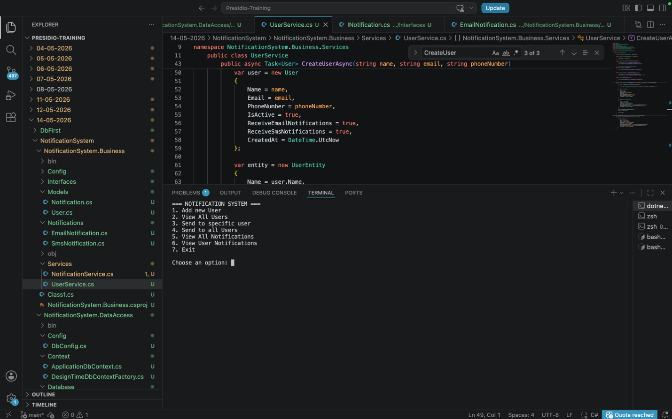

Add New user:
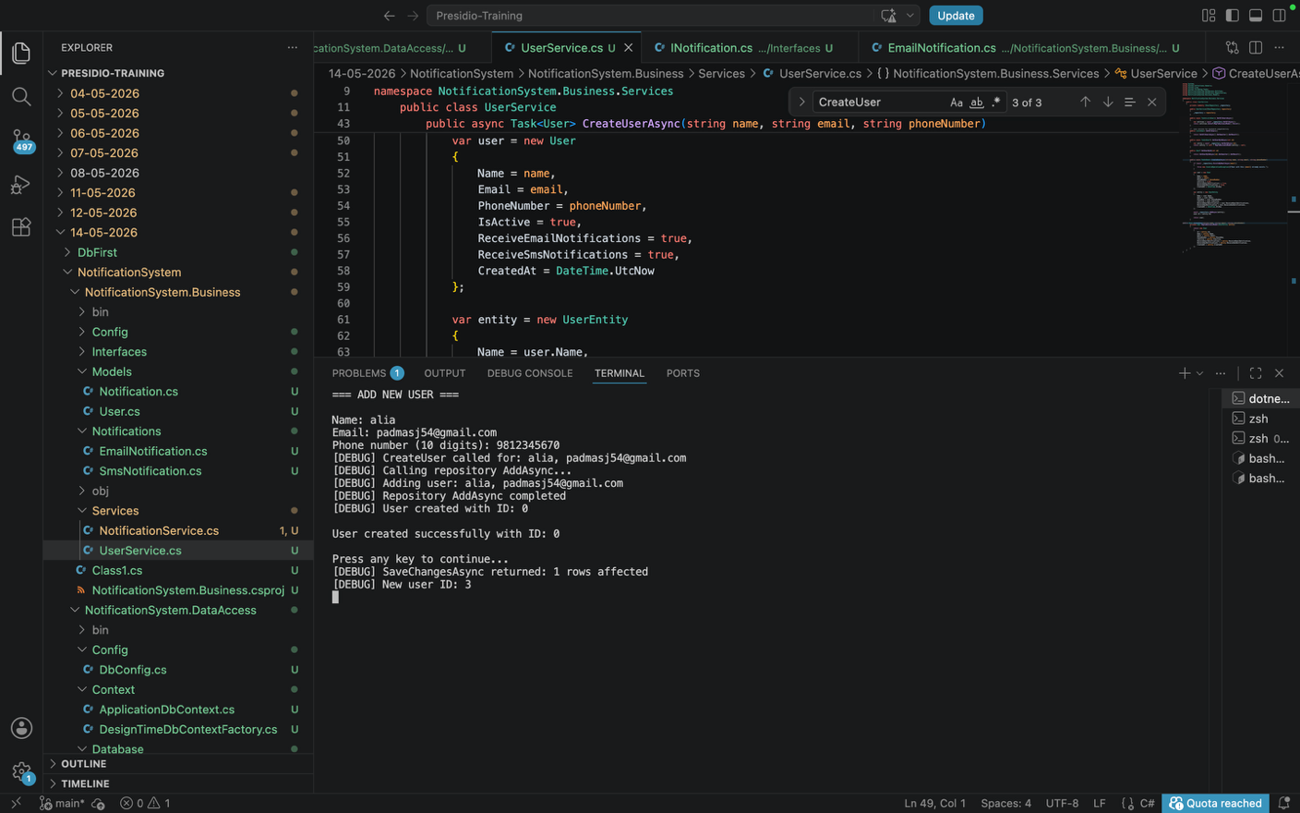
View all users:
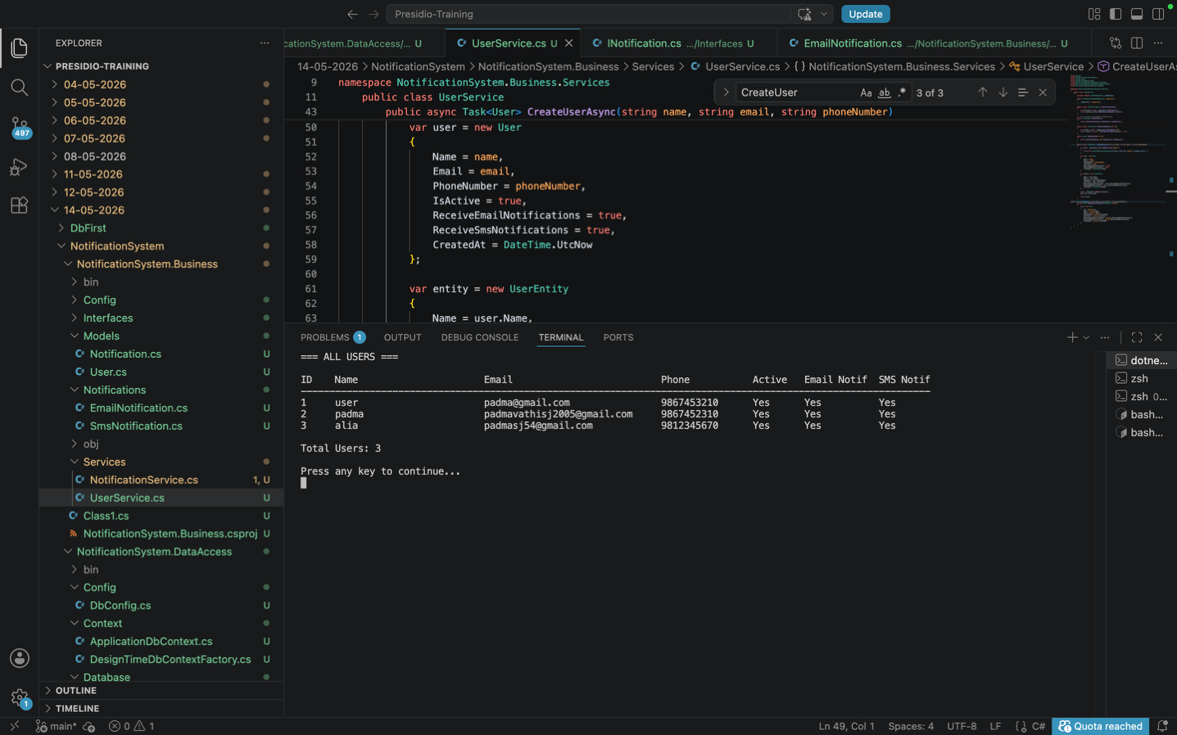
View all sent notifications before sending notification to newly created user(alia):
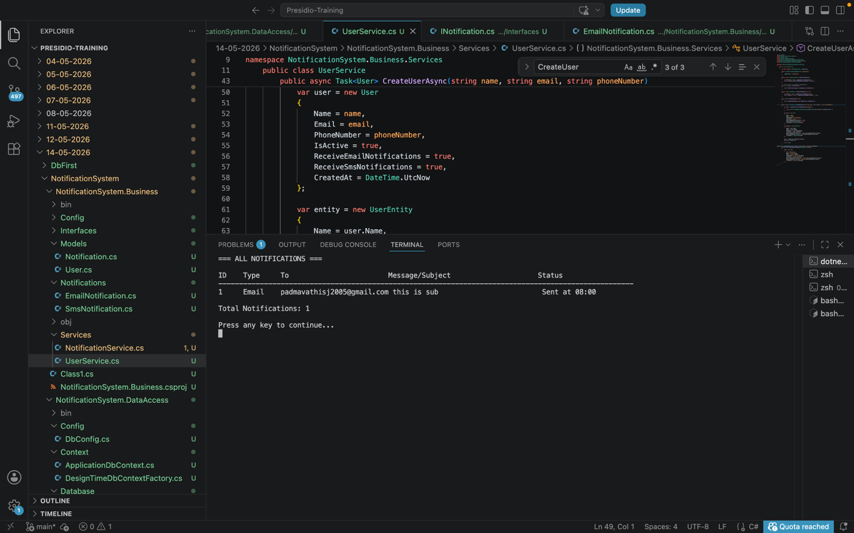
Send notification to specific user(alia):
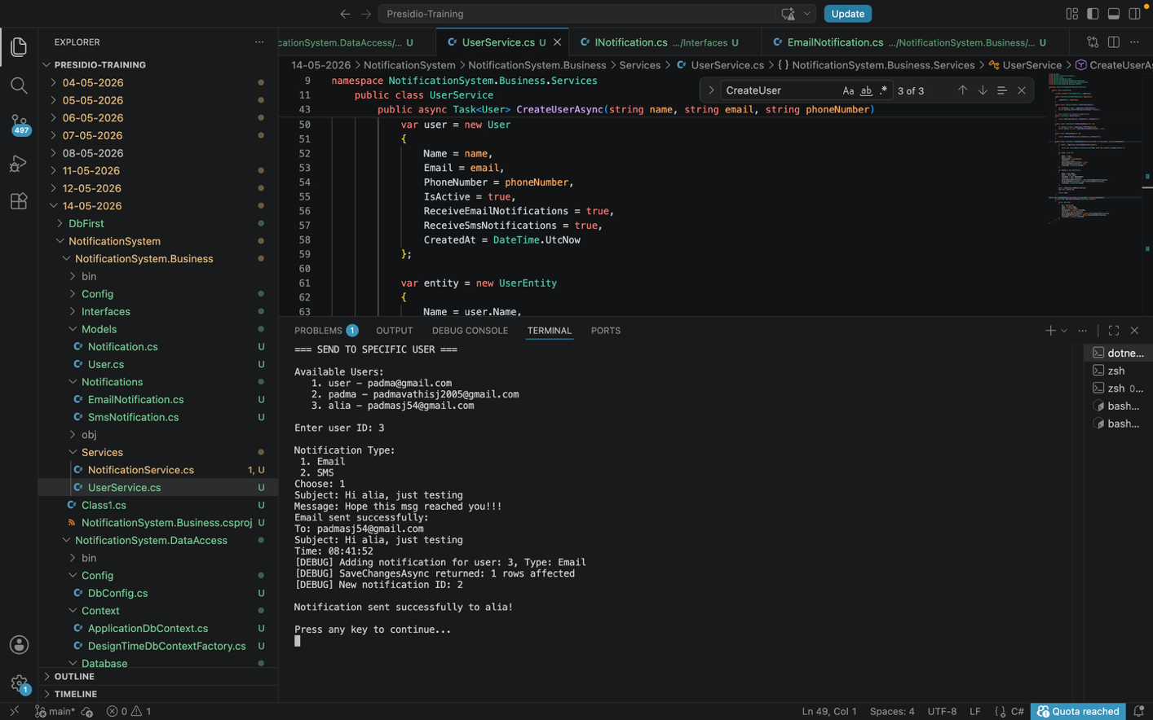
View all sent notifications after sending notification to newly created user(alia):
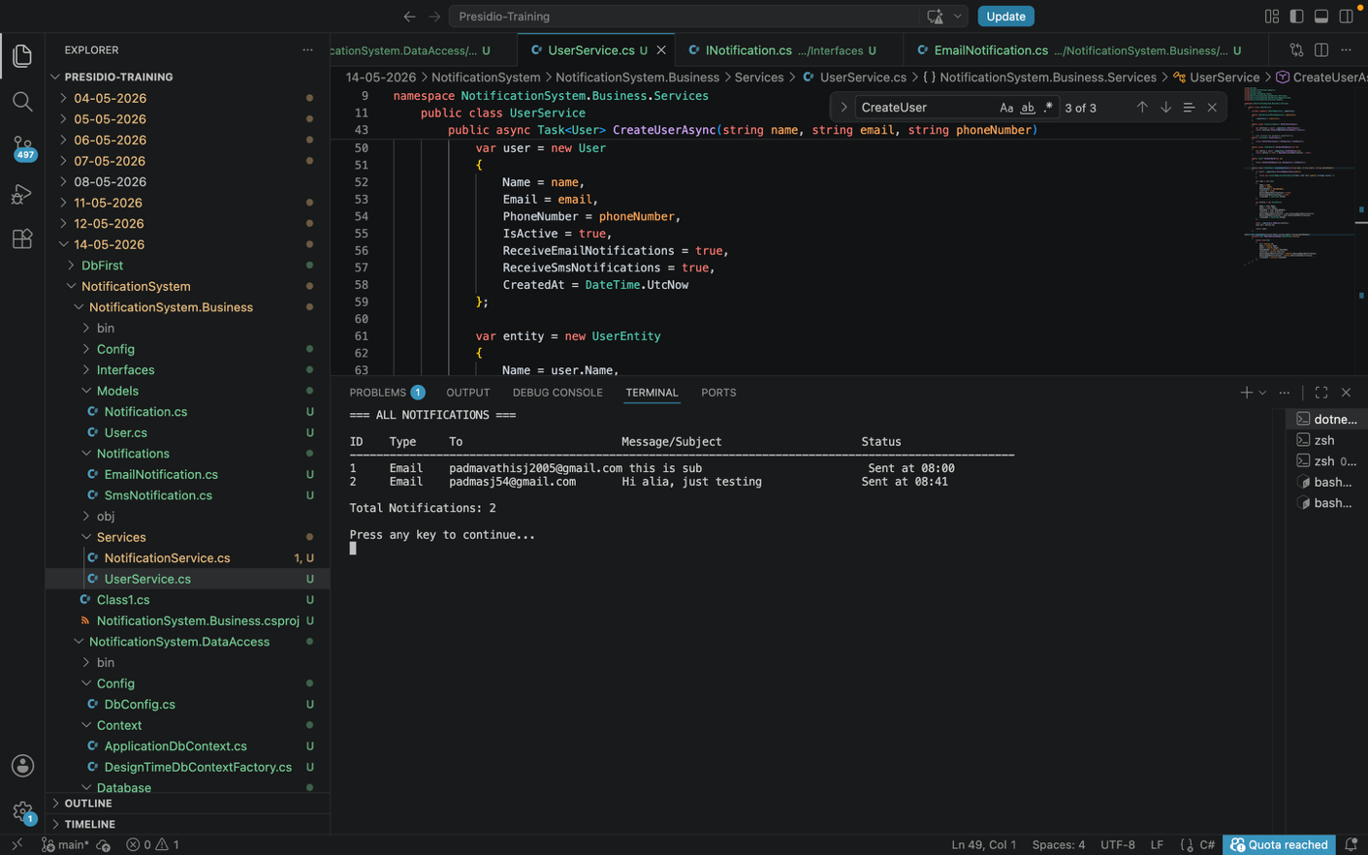
View notifications of a specific user:
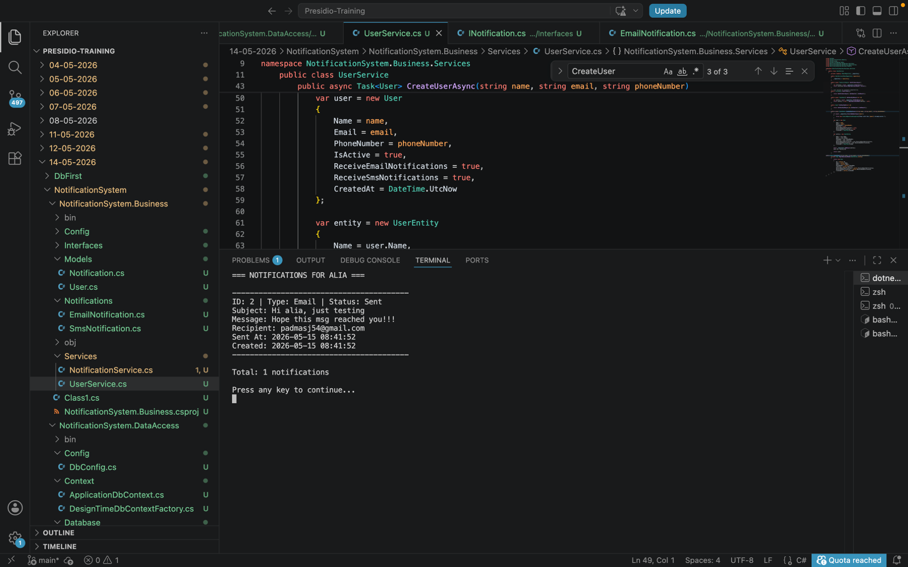
Send notifications to all users:
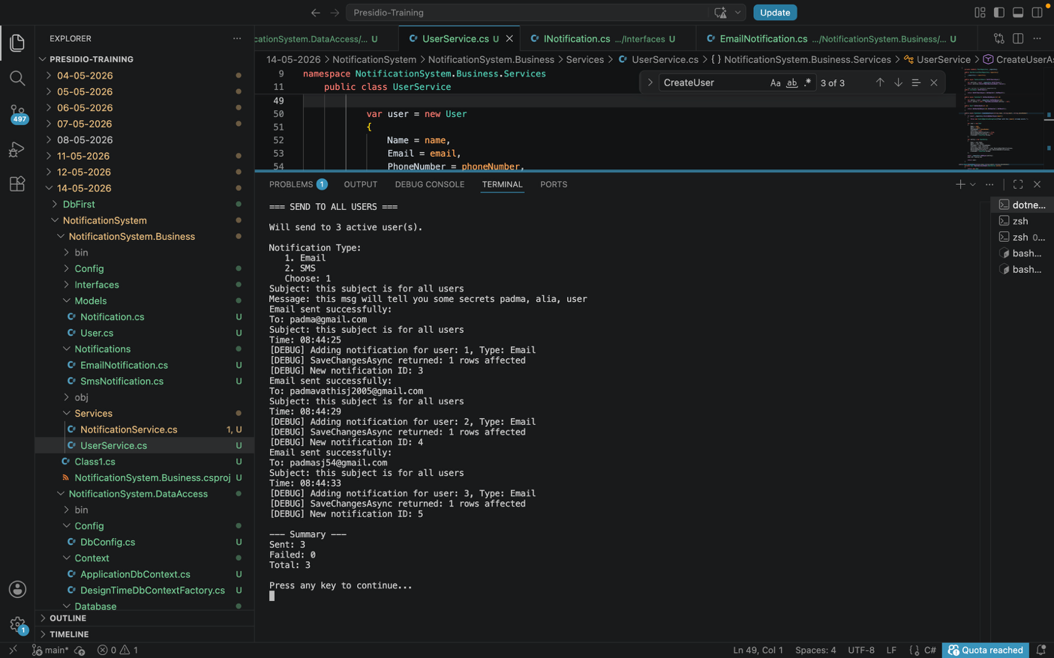
View all sent notifications:
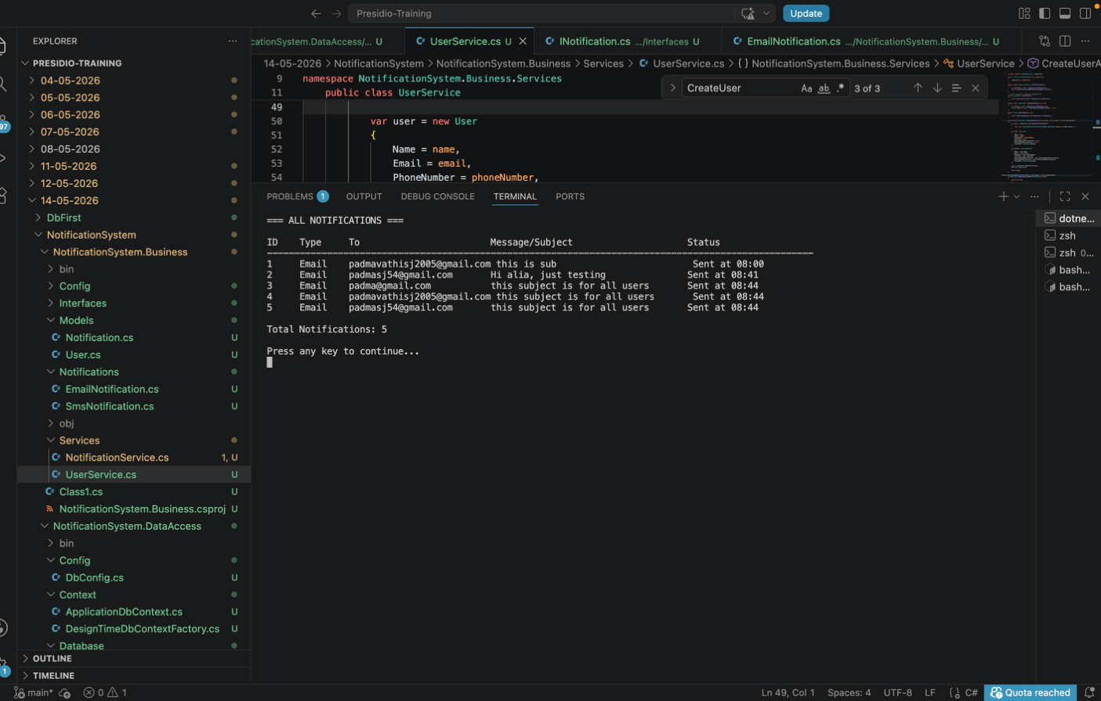
Users table:
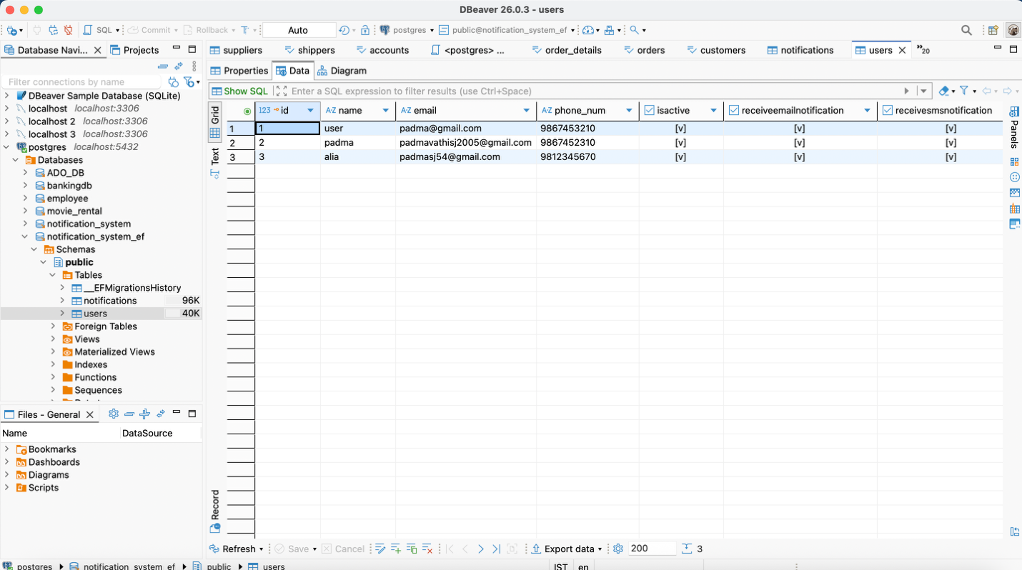

Notifications table:
